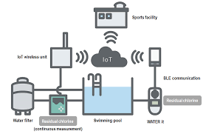

Water quality monitoring :

Monitoring provides this basic information. There are many ways to monitor water conditions. Monitoring specialists sample the chemical condition of water, sediments, and fish tissue to determine levels of key constituents such as dissolved oxygen, nutrients, metals, oils, and pesticides

Parts of water quality monitoring:

They include stream flow, dissolved oxygen and biochemical oxygen demand, temperature, pH, turbidity, phosphorus, nitrates, total solids, conductivity, total alkalinity, and fecal bacteria.

Water monitoring tools:

Water monitoring sensors, from simple piezometric instruments to state-of-the-art Acoustic Doppler Current Profilers (ADCPs)

Sensor:

TOC Sensor - Total organic carbon (TOC) is an important parameter for water quality analysis. It is used as a direct indicator and a surrogate for many water quality purposes. There are two different TOC measurement devices available on the market: TOC analyzers and TOC sensors.

Using components:

There are 4 components of water quality:

 Sanitizer,

Total alkalinity,

PH balance,

Calcium hardness.

Equipments:  
  
  Turbidity meters,

Water level meters,

Hardness test kit,

Multi-parameter water quality meters